**Overview:**

This R script pairs and classifies synapses as pillar or modiolar. Specifically, it pairs immunopuncta by calculating 3D Euclidean distances between pre- and postsynaptic volumes. It then classifies the paired volumes as pillar or modiolar by calculating a plane that defines the inner ear hair cell pillar-modiolar axis. Data are plotted in 3D figures and exported as an Excel file (.xlsx). This protocol requires RStudio, Excel and Imaris (or equivalent software for calculating x,y,z coordinates and volumes for immunopuncta). Separate instructions on using imaris can be found at <http://thepyottlab.com/pillar-modiolar>.

**Please cite:**

Reijntjes DOJ, Köppl C, Pyott SJ. 2020. Volume gradients in inner hair cell-auditory nerve fiber pre- and postsynaptic proteins differ across mouse strains. Hear Res. 390:107933. PMID: 32203820.

**Additional references:**

Barone CM, Douma S, Reijntjes DOJ, Browe BM, Köppl C, Klump G, Park TJ, Pyott SJ. 2019. Altered cochlear innervation in developing and mature naked and Damaraland mole rats. J Comp Neurol. 527(14):2302-2316. PMID: 30861124.

**Procedure:**

1. In Imaris, import the confocal stack for analysis. Three features need to be processed in Imaris. 1) Use the “surface” function to determine the volumes of the pre- and postsynaptic immunopuncta. 2) Use the “spots” function to mark the inner hair cell nuclei. 3) Use the “spots” function to mark a single spot each in the pillar versus modiolar space.
2. 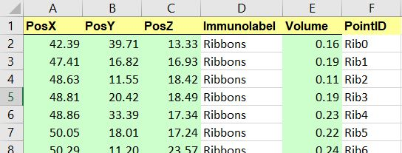Export these volumes and x, y, z coordinates from Imaris for further analysis in R. Column names (case sensitive!) and positions should be organized as shown below and in the attached example file attached. In case no volume information is available or needed, add 0 in all Volume cells to allow the script to function.

*Note: The R script requires Excel (.xlsx) files that are organized as shown above. Organization of this Excel file will need to be done manually. Alternatively, this Excel file can be generated automatically using a custom-made script that organizes the file outputs of your preferred image analysis software into a file with the required layout. Contact authors listed above to request such a script.*

1. Before starting analysis, create an empty folder and add the following files: medianorm.R, separate_points.R, get_couples.R, Synapse_script.R.
2. Double click on Synapse_script.R to open the file in RStudio.
3. Follow the instructions in the script. The following steps are essential:
   1. Add all .xlsx files (with the layout described in Step 2) to be analyzed into the same folder created in Step 3.
   2. Set the working directory in R to the folder created in Step 3.
   3. Make sure the “readxl” and “rgl” packages are installed and loaded.
   4. Set immunolabel identifiers (i.e., “Ribbons” and “PSD”).
   5. If results should be visualized in a 3D plot, set “figures = TRUE”. Note that calculations take considerably longer when visualization is enabled.
   6. Run the script by clicking on the “Source” button.
4. The script will now: 1) normalize immunolabel volumes by dividing them by their respective median values; 2) pair pre- and postsynaptic volumes by calculating Euclidean distances between and determining pairs as those with the closest distances; and 3) classify paired volumes as pillar or modiolar by defining a pillar-modiolar axis determined by the inner hair cell nuclei and markers of the pillar and modiolar space.
5. 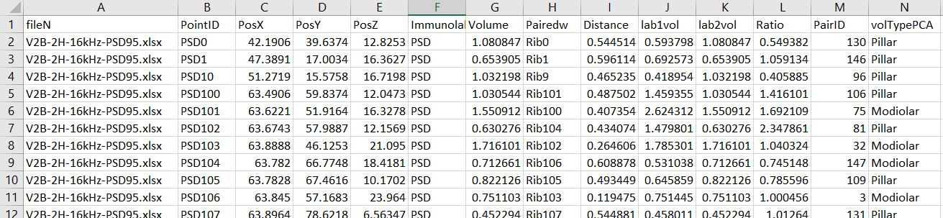Results are visualized in a 3D plot in RStudio and exported as an Excel file (.csv format) titled “Results” into the working directory folder created in Step 3. The output format is shown below.

The first column (A) titled “fileN” contains the filename. All results, including when multiple files were added to the data folder, are shown in the exported “Results.csv” file.

Columns B to G contain Point ID, x, y, z coordinates, Immunolabels and Volumes of an immunopunctum, with columns H and I containing the immunopuncta pair and Euclidean distance. Columns J and K contain the median normalized volumes of both immunopuncta, with column L containing the ratio between the two. Column M contains a unique ID assigned to the immunopuncta pair.

Column N contains the pillar / modiolar classification.